**CN Lab Experiment 4**

**Objective:**

In this experiment, you will configure IP addressing using Variable Length Subnet Masking (VLSM) for a network. You will create subnets of different sizes to optimize IP address utilization, and configure routers and PCs to use these subnets. This will demonstrate efficient IP address allocation using VLSM.

**Requirements:**

* Cisco Packet Tracer software.
* A GitHub account and a repository for lab assignments.
* Access to Google Classroom for submission.

**Procedure:**

**Step 1:**

1. Identify the major network address:

○ Example: 192.168.0.0/24

2. Determine the number of subnets and their sizes:

○ Subnet 1 (e.g., 50 hosts): Network Address: 192.168.0.0/26 (Subnet Mask: 255.255.255.192)

○ Subnet 2 (e.g., 30 hosts): Network Address: 192.168.0.64/27 (Subnet Mask: 255.255.255.224)

○ Subnet 3 (e.g., 10 hosts): Network Address: 192.168.0.96/28 (Subnet Mask: 255.255.255.240)

○ Subnet 4 (e.g., 5 hosts): Network Address: 192.168.0.112/29 (Subnet Mask: 255.255.255.248)

**Step 2: Configuring Router**

1. Select the router and open CLI.

2. Press ENTER to start configuring Router1.

3. Activate privileged mode:

○ Type enable

4. Access the configuration menu:

○ Type config t (configure terminal)

5. Configure interfaces of Router1:

○ FastEthernet0/0:

■ Type interface FastEthernet0/0

■ Configure with the IP address 192.168. 0.1 and Subnet mask 255.255.192.0

○ FastEthernet0/1:

■ Type interface FastEthernet0/1

■ Configure with the IP address 192.168.20.1 and Subnet mask 255.255.255.0

6. Finish configuration:

○ Type no shutdown to activate the interfaces

**Step 3: Configuring PCs**

1.Assign IP addresses to each PC:

○ PC0:

■ Go to the desktop, select IP Configuration, and assign the following:

■ IP address: 192.168.0.2

■ Subnet Mask: 255.255.255.192

■ Default Gateway: 192.168.0.1

○ PC1:

■ Go to the desktop, select IP Configuration, and assign the following:

■ IP address: 192.168.0.66

■ Subnet Mask: 255.255.255.224

■ Default Gateway: 192.168.0.65

**Step 4: Connecting PCs with Router**

1. Connect the devices using copper straight-through cables:

○ Connect FastEthernet0 port of PC0 to FastEthernet0/0 port of Router1

○ Connect FastEthernet0 port of PC1 to FastEthernet0/1 port of Router1

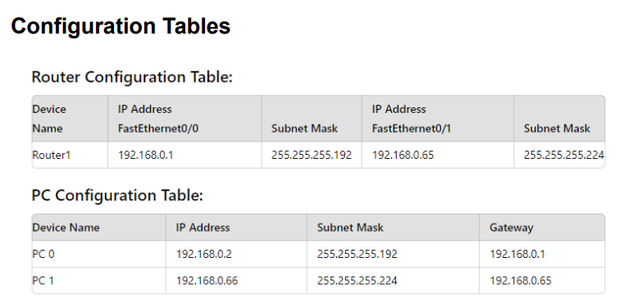

**Results:**

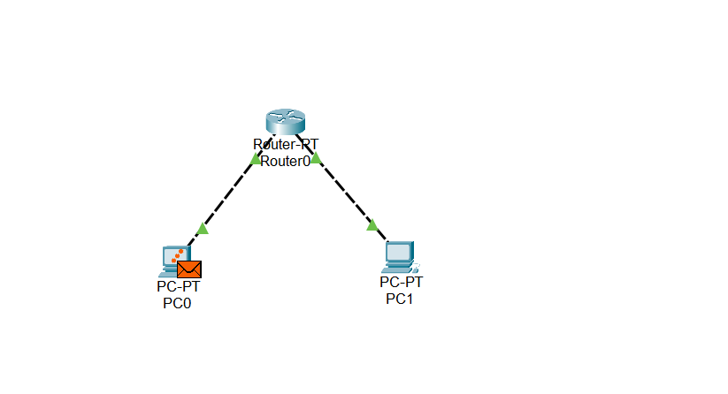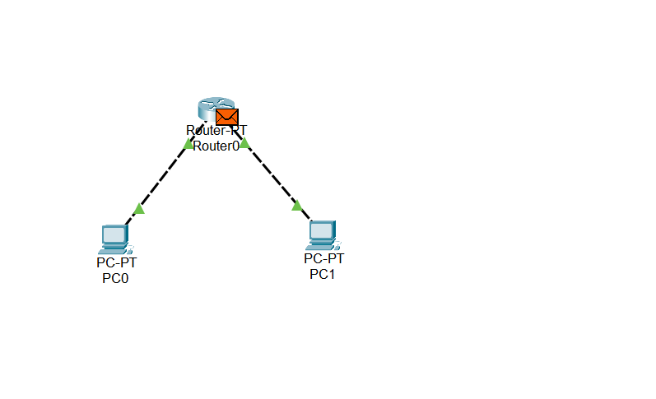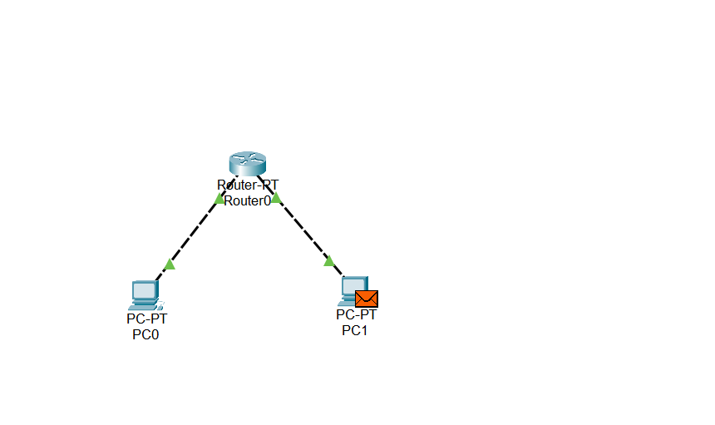

* We observe the packet traveling from PC0 to the router and then to PC1.
* The acknowledgment packet travels back from PC1 to PC0, confirming successful communication.